**Principles of genetics**

Gregor Johann Mendel was the first scientist to explain the mechanism of inheritance even before the discovery of existence of chromosomes and laid the foundation for the science of genetics. Hence, he is called as “Father of Genetics”. Johann Mendel was born on July 22, 1822 in the village of Heinzendorft, in the region of the Austria-Hungary Empire called Moravia.

Mendel conducted his breeding experiments in garden pea, Pisum sativum for nearly nine years from 1856. His classical experiments and his explanations were reported in 1865 to the Bruno Society for the Study of Natural Science and published as “Experiments in Plant Hybridization”, in The Annual Proceedings of the Natural History Society of Brunn in 1866.

His contributions remained unnoticed. Mendel died at the age of 61 in 1884. In 1900, three botanists, Karl Correns of Germany, Hugo de Vries of Netherlands and Erich von Tschermak of Austria independently rediscovered Mendel’s work and laws.

This marked the beginning of modern genetic research. Mendel’s original paper was later republished in 1901 in the journal ‘Flora’ (Vol. 89 Page 364).

REASONS FOR SELECTION OF GARDEN PEA

The principles of inheritance explained by Mendel was based on his experiments with garden pea (Pisum sativum). He selected garden pea as

(i) It has a short life cycle, which makes it possible to study several generations within a short period (ii) Its self pollinating, bisexual nature with the presence of contrasting characters makes it easy to get true breeding lines

(iii) It is easy to produce hybrids by transferring pollen from one plant to another. REASONS FOR

MENDEL’S SUCCESS The key reason for Mendel’s success was that

1. He approached the problem of inheritance in a systematic and quantitative way
2. (ii) He applied laws of probability to his results
3. (iii) He chose true-breeding garden pea varieties with observable contrasting traits.
4. (iv) He kept records of his experiments and subjected his results to simple mathematical analysis
5. (v) He was lucky as the traits selected him showed complete dominance i.e. they were governed by a single gene and segregated independently in dihybrid crosses.

MENDEL’S PRINCIPLES OF INHERITANCE

The consistent results from different monohybrid crosses led Mendel to propose postulates, which have been called as Principles of inheritance. Mendel’s ‘factors’ were later recognized as genes. The postulates of Mendel were referred to as Principles of inheritance and not as Laws of Mendel as deviations were observed.

1. Principle of dominance

When two homozygous individuals with a contrasting character are crossed the character that appear in the F1 hybrid is called as dominant character and the condition is termed as dominance. The parent is referred to as dominant parent. The character that does not appear in the F1 but appear in the F2 generation is called as recessive character, the condition is called as recessive and the parents as recessive parents.

2. Principle of Segregation or Purity of gametes

The principle of segregation states that allelic pairs in a heterozygote (F1) do not contaminate each other but segregate or separate equally during gamete formation and are again paired by the random fusion of gametes during fertilization

3. Principle of independent assortment

The principle of independent assortment states that if the inheritance of more than two or more pairs of genes is considered, the distribution of their alleles in the gametes and in the progeny of subsequent generation is independent of each other.

EXCEPTIONS TO MENDEL’S PRINCIPLES

1. Polyploidy and mutations are exceptions to the Mendel’s principle of segregation.

2. Linkage is an exception to Mendel’s principle of independent assortment.

3. Incomplete dominance is an exception to Mendel’s principle of dominance.

4. Pleiotropism is an exception to the principle of unit characters.

5. Modification of F2 ratios due to incomplete-dominance, co-dominance, lethal genes, gene interaction, epistatic factors are all exceptions to Mendel’s principles.

GENE INTERACTION

The phenomenon of two or more non-allelic genes affecting the expression of each other in the development of a single character of an organism is known as gene interaction or epistasis. The gene which masks the expression of the other gene is referred to as epistatic gene. The gene which is being masked is known as hypostatic gene.

Genes interaction is the influence of alleles and non-alleles on the normal phenotypic expression of genes. It is of two types :

(1) **Inter–allelic or intra–genic gene interaction :**In this case two alleles (located on the same gene locus on two homologous chromosomes) of gene interact in such a fashion to produces phenotypic expression *e.g.,*co-dominance, multiple alleles.

(i) **Incomplete dominance or Blending inheritance (1: 2:1 ratio) :**After Mendel, several cases were recorded where F1 hybrids were not related to either of the parents but exhibited a blending of characters of two parents. This is called incomplete dominance or blending inheritance.Example : First case of incomplete dominance or blending inheritance was reported in 4-O’clock plant, (*Mirabilis jalapa*) by Carl Correns (1903) when plants with red flowers (RR) are crossed with plants having white flowers (rr) the hybrid

F1 plants (Rr) bear pink flowers. When these F1 plants with pink flowers are self pollinated they develop red (RR), pink (Rr) and white (rr) flowered plants in the ratio of 1:2:1 (

F2 generation). Snapdragon or dog flower (*Antirrhinum majus*) is a other example of in complete dominance.

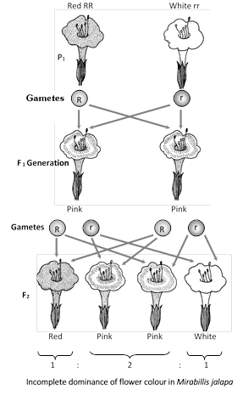

(ii) **Codominance (1:2:1 ratio) :**In codominance, both the genes of an allelomorphic pair express themselves equally in F1 hybrids. 1:2:1 ratio both genotypically as well as phenotypically in F2 generation. Example**:**Codominance of coat colour in cattle, Codominance in and alusian fowl and Codominance of blood alleles in man.

**Differences between incomplete dominance and codominance**

|  |  |
| --- | --- |
| **Incomplete dominance** | **Codominance** |
| Effect of one of the two alleles is more conspicuous. | The effect of both the alleles is equally conspicuous. |
| It produces a fine mixture of the expression of two alleles. | There is no mixing of the effect of the two alleles. |
| The effect in hybrid is intermediate of the expression of the two alleles. | Both the alleles produce their effect independently, e.g., IA  and IB, HbS and HbA. |

(2) **Non–allelic or inter-genic gene interaction :**Here two or more independent genes present on same or different chromosomes, interact to produce a new expression *e.g.,*epistasis, complementary genes, supplementary genes, duplicate genes, inhibitory genes, lethal genes etc.

(i) **Complementary genes (9 : 7 ratio) :** The complementary genes are two pairs of nonallelic dominant genes (*i.e.,* present on separate gene loci), which interact to produce only one phenotypic trait, but neither of them if present alone produces the phenotypic trait in the absence of other.

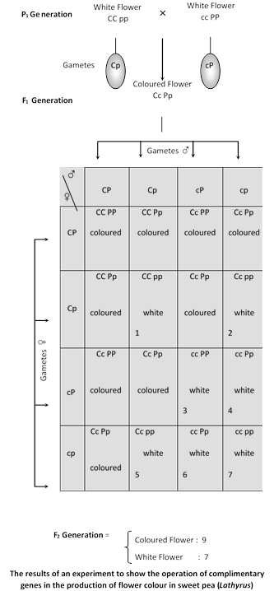

(ii) **Supplementary genes (9 : 3 : 4 ratio) :** Supplementary genes are two independent pairs of dominant genes which interact in such a way that one dominant gene will produce its effect whether the other is present or not. The second dominant when added changes the expression of the first one but only in the presence of first one. In rats and guinea pigs coat colour is governed by two dominant genes.

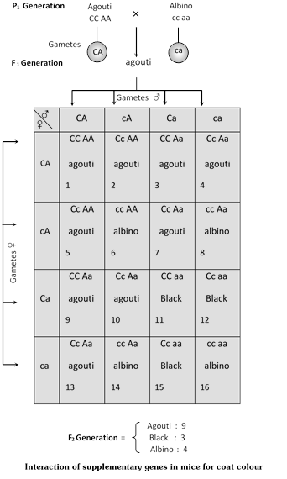

(iii) **Epistasis (Inhibiting genes) :**Epistasis is the interaction between nonallelic genes (Present on separate loci) in which one-gene masks, inhibits or suppresses the expression of other gene. The gene that suppresses the other gene is known as inhibiting or epistatic factor and the one, which is prevented from exhibiting itself, is known as hypostatic.

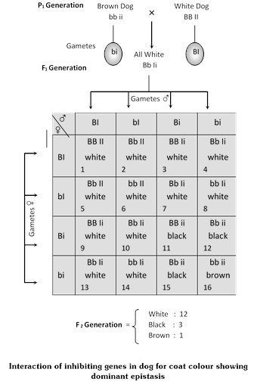

**Dominant epistasis (12:3:1 or 13:3 ratio) :**In dominant epistasis out of two pairs of genes the dominant allele, (*i.e.,* gene A) of one gene masks the activity of other allelic pair (Bb). Since the dominant epistatic gene A exerts its epistatic influence by suppressing the expression of gene B or b, it is known as dominant epistasis. Example – Dominant epistasis in dogs

Similar phenomena have been seen in fruit colour in cucurbita as summer squash and coat colour in chickens.

**Recessive epistasis (9:3:4 ratio) :**Epistasis due to recessive gene is known as recessive epistasis, *i.e.*, out of the two pairs of genes, the recessive epistatic gene masks the activity of the dominant gene of the other gene locus. The dominant A expresses itself only when the epistatic locus C also has the dominant gene if the epistatic locus has recessive gene c, gene A fails to express.

(iv) **Duplicate genes** 15:1**ratio) :**Sometimes two pairs of genes located on different chromosomes determine the same phenotype. These genes are said to be duplicate of each other. The dominant triangular fruit shape of *Capsella bursa pastoris* (shepherd’s purse) is determined by two pairs of genes, say A and B. If any of these genes is present in dominant form, the fruit shape is triangular. In double recessive forms the fruits are top shaped and thus we get a 15 (triangular) : 1 (top shaped) ratio in F2 generation.

Example : Coat colour of mice.

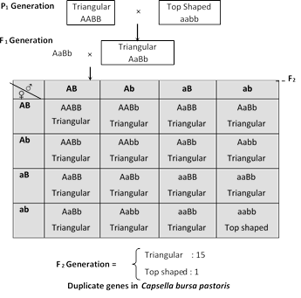

(v) **Collaborator genes** : In collaboration two gene pairs, which are present on separate loci but influence the same trait, interact to produce some totally new trait or phenotype that neither of the genes by itself could produce.

Example : Inheritance of combs in poultry, where two genes control the development of comb.

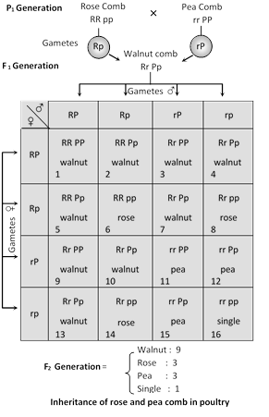

**Pleiotropic effect of genes**

**Lethal genes :**Lethal factor were first of all reported in mice body by of French geneticst 'Cuenot'. Certain genes are known to control the manifestation of some phenotypic trait as well as affect the viability of the organism. Some other genes have no effect on the appearance of the organism but affect the viability alone. These genes are known as lethals or semilethals depending upon their influence. Lethal factors in case of plants were reported first of all in snapdragons (*Antirrhinum majus*) by E. Baur (1907).

**Dominant lethals :**The dominant lethal genes are lethal in homozygous condition and produce some defective or abnormal phenotypes in heterozygous condition. Their most serious effect in heterozygous may also cause death. Following are the examples of dominant lethal genes.

Example – Yellow lethal in mice : A well known example of such lethals is from mice, given by Cuenot. He found that the yellow mice never breed true. Whenever the yellow mice were crossed with yellow mice, always yellow and brown were obtained in the ratio of 2:1. A cross between brown and brown mice always produced brown offsprings and a cross between brown and yellow produced yellow and brown in equal proportions. Yellow mice never present homozygous condition.

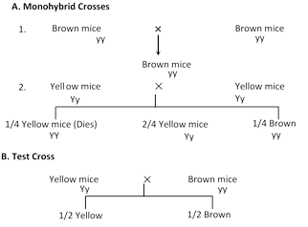

In 1917, Stiegleder concluded that yellow mice are heterozygous. The homozygous yellow (1/4th of the total offsprings) dies in the embryonic condition. When there unborn ones are added to the 2:1 ratio of yellow and brown, these form typical 3:1 ratio. Cuenot suggested that gene Y has a multiple effect. It controls yellow body colour and has a dominant effect. It affects viability and acts as a recessive lethal. Other examples are Inheritance of sickle cell anaemia in man, Brachyphalangy, Huntington’s chorea in man.

MULTIPLE ALLELES

Usually two alleles of a gene govern the contrasting form of a trait. For example, plant height has two alleles, T for tall and t for dwarf condition. In some cases, a trait may be governed by three or more number of alleles. Many alleles of a single gene controlling different forms of a single character is known as multiple alleles. Eg. Inheritance of coat colour in rabbit, inheritance of blood group in man and self incompatibility in plants.

1. Inheritance of Blood Group in Man

Karl Landsteiner (1900) classified blood group of human beings into four types based on the presence or absence of certain antigens. The ABO blood group system is believed to be controlled by a single gene, designated as I. The gene I has three alleles ; I A, IB and I°. Allele IA controls the production of antigen A, allele IB determines antigen B, while allele i (I°) does not produce any active antigen. These alleles are codominant so that individuals having the genotype IAIB have both the antigens A and B on their RBC and hence have AB blood group. Individuals with the genotype IAI A or I Ai produce antigen A and are classified into the blood group A; those with the genotype IBIB or IBi produce antigen B and belong to the group B; persons with the genotype IAIB have both the antigen A and B and are placed into the group AB. Those individualwith the genotype ii (II) produce neither A nor B and are classified into the group 0.

. Coat Colour in Rabbit

The coat colour of rabbits is determined by the C gene. The C gene has multiple allelic forms that lead to varied phenotypes. The different phenotypes for coat colour in rabbits are agouti (full colour), chinchilla, Himalayan and albino.

The four common allele of C gene are C, cch, ch and c. A rabbit with genotype CC has black or brown fur, cchcch have chinchilla or greyish coat colour, chch have Himalayan pattern and cc have white coat colour, i.e. albino.

Due to multiple alleles, there are many combinations of alleles possible.

The black C allele is dominant over the other three alleles.

The cch (chinchilla) allele shows incomplete dominance over Himalayan and albino alleles.

The ch (Himalayan) allele shows dominance over the albino allele (c).

3. Eye Colour in Drosophila

The eye colour in Drosophila is another trait that is determined by multiple alleles. There are a dozen different alleles that show phenotype between the wild-type red colour (w+) and white colour (w). E.g. coral, blood, eosin, cherry, apricot, etc. The wild-type red colour is dominant over all other mutant alleles and the white colour is recessive to all the alleles.

LINKAGE

T. H. Morgan (1911) proposed the theory of linkage. Every species has a specific number of chromosomes. Each chromosome carries many genes. The genes located in the same chromosome very near to each other cannot assort independently and are inherited together. The phenomenon of inheritance of genes together maintaining the parental combination is known as linkage or complete linkage. When new recombinants, in addition to the parental characters are also present it is called as incomplete linkage. The genes are called linked genes and the characters controlled by them as linked characters. The maximum number of genes linked as a group in an organism is equal to the number of chromosome pairs. Eg. Drosophila has 4 linkage groups while a human being has 23.

MAIN FEATURES OF LINKAGE

The main features of linkage and the linked genes are as follows:

1. The linked genes are located in the same chromosome,
2. The linked genes are in linear order
3. The linked genes retain their original parental combination during inheritance

(iv) The distance between he linked genes is inversely proportional to the length of the genes

1. Linked genes do not show independent segregation hence the F2 and test-cross ratios are altered.

COUPLING AND REPULSION PHASES OF LINKAGE

Bateson and Punnet in 1905 studied the inheritance of flower colour and pollen shape in sweetpea. They observed that the test cross result does not agree with the Mendelian ratio. The usual test cross ratio of 1:1:1:1 was modified to 7:1:1:7. The result of test cross indicate that the parental combinations are seven times more than the non-parental combinations. Bateson and Punnet observed that, when the two dominant alleles on one chromosome and two recessive alleles on the other chromosome have an affinity for each other and tend to stay together during inheritance it is called as coupling phase linkage.

On the other hand, when one dominant allele for first character and one recessive allele for the second character are located in the same chromosome and tend to stay together during inheritance, the condition is called as repulsion phase linkage.

ARRANGEMENT OF LINKED GENES

1. cis-arrangement When both the dominant alleles are located in the same chromosome and their recessive alleles are located in the other member of the pair the condition is called as cis-arrangement (C Sh/c sh).

2. trans-arrangement When a dominant allele for first character and a recessive allele for second character are located in the same chromosome the condition is called as trans-arrangement (C sh/c Sh).

CYTOPLASMIC INHERITANCE/ EXTRACHROMOSOMAL INHERITANCE

DNA in the nucleus is the universal genetic material. However, not all the genetic material of a cell is found in the nucleus. Some traits are governed by genes present in the cytoplasm. Those traits which are transmitted by DNA in cytoplasmic organelles are called as cytoplasmic inheritance. They are also referred to as extra-nuclear inheritance, non-Mendelian inheritance and maternal inheritance. As the genes for cytoplasmic inheritance are located in the cytoplasm, they are referred to as plasmagenes, cytoplasmic genes, extra-nuclear genes or extra-chromosomal genes. Plasmagenes are located in the DNA present in mitochondria (mt –DNA) and chloroplasts (cp–DNA); together these DNA’s are termed as organelle DNA. Cytoplasmic inheritance was first reported by Carl Correns (1909) while studying the inheritance of leaf variegation in Mirabilis jalapa.

FEATURES OF CYTOPLASMIC INHERITANCE

1. In most organisms, the cytoplasm of the offspring is inherited from the mother. Hence, the cytoplasmically inherited characters are passed only from mother to offspring and never from the father.

2. As a result, reciprocal crosses (AxB; BxA) exhibit differences and deviate from Mendelian pattern.

3. Cytoplasmic genes are not uniformly distributed during cell division. Hence, there is an extensive phenotypic variation as the cells of an individual will contain cytoplasmic genes in various proportions. Usually the females has more influence on the trait as they carry more cytoplasm than the male.

4. Unlike nuclear genes which show linkage, the extra-nuclear genes fail to show linkage.

MITOCHONDRIA AND CYTOPLASMIC INHERITANCE

Organelles like mitochondria and chloroplasts contain DNA. Mitochondria are presently considered as living organisms. The mitochondrial DNA (mtDNA) is a circular molecule ranging from 16 kb to several hundred kilobase pairs. The mtDNAs of humans, mice and cattle exhibit the same basic organization. Each mtDNA has 2 rRNA genes, 22 tRNA genes and 13 structural genes. The entire mtDNA is equivalent to one operon in bacteria. The human mitochondrion contain about 15,000 nucleotides and enclodes 37 genes while the nuclear DNA contains 3 billion nucleotides and encodes 35,000 genes.

PLASTID INHERITANCE

Inheritance of characters due to genes located in plastids is known as plastid inheritance. This was the first case of cytoplasmic inheritance to be discovered by Correns and Baur in 1908. Leaves of Mirabilis jalapa, the four 0’ clock plant, may be green, white or variegated. Correns made reciprocal crosses in all combinations among the flowers produced on these three types of branches. When flowers from a green branch are used as female, all the progeny are green irrespective of the phenotype (green, white or variegated)